Budget Tracker

Installation Document

By Malik Johnson

Fall 2019

**Table of contents**

1. Installing increment 1 ------ Page #3
2. Increment 1 overview. -------Page #3
3. The JRE -------Page #3
4. The Oracle database -------Page #3
5. SQL developer ---------Page #3
6. Budget Tracker Software ------Page #3
7. Installing the JRE. -------Page #4
8. Downloading the Oracle Database. ----Page #6
9. Installing the Oracle database. -----Page#7
10. Downloading SQL developer. ------Page#11
11. Installing the BudgetTracker.jar file. -----Page#13
12. Installing increment 2 ---------Page#16
13. Remove old executable file ---------Page#16
14. Add new executable file -----------Page#16
15. Installing increment 4 -------------Page#17
16. Remove old executable file --------------Page#17
17. Add new executable file ---------------Page#17
18. Make database changes -----------------Page#17
19. Installing increment 6 --------------------Page#19
20. Remove old executable file -------------------Page#19
21. Add new executable file -----------------Page#19
22. Make database changes ------------------Page#19

**Installing Increment 1**

There are four main things to install for the Budget Tracker application to work. The Java Runtime Environment(JRE), an Oracle Express Database, SQL developer, and the executable jar file for Budget Tracker.

**The JRE**

This is the main piece that will allow you to run the Java application. It can be found on the Oracle website. From there type JRE into the search bar. Click Java download central. From there locate JRE and download.

**Oracle Database**

The program creates and modifies data in an oracle database. To get the database you must visit the Oracle website. To build the database you will process SQL statements in SQL developer. This may come with the Oracle database. The SQL statements will create the tables, sequences, and rules necessary. It is as easy as copying the SQL text into SQL developer and clicking run.

**SQl developer**

This program is used to build the database. It may not come downloaded with oracle. But it can be found on the website with a simple search.

**Budget Tracker Jar**

The last piece to run the program is an executable jar. This JAR may change with each increment but will be named BudgetTracker.jar.

**How to install the JRE**

1. Visit the Oracle website.
2. Search for JRE or Java runtime environment.
3. Click the Java download central link.
4. Find Java SE JRE download and click the download button. 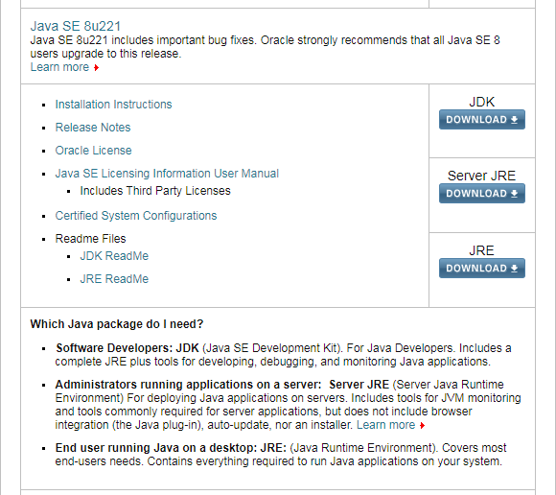

.

5. Find the verison of the JRE for your machine. Accept the lisence agreement. And then click download. 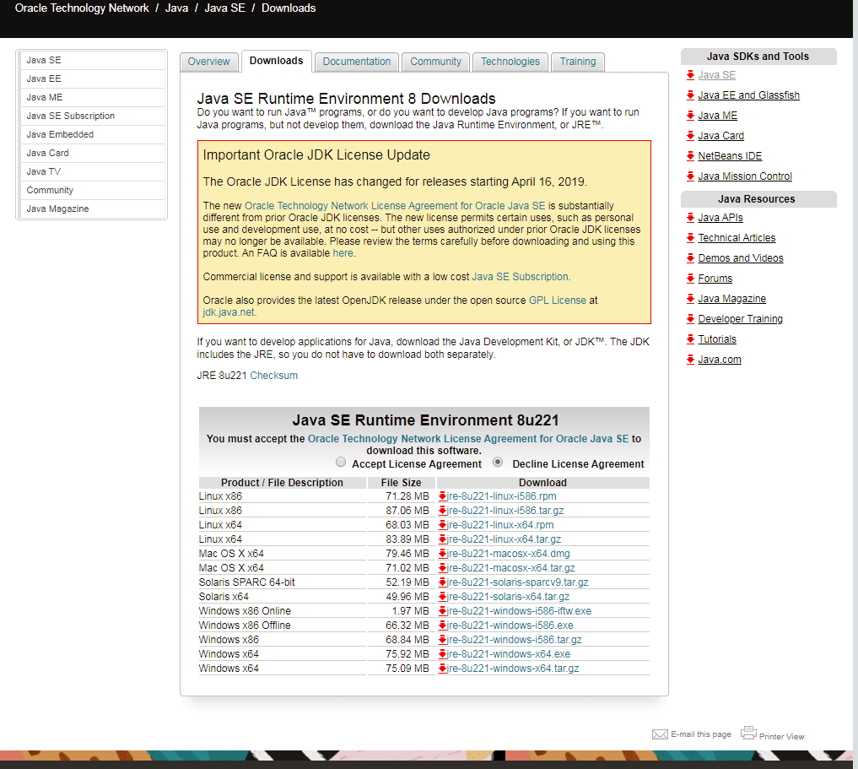

1. After downloading the JRE. Run the installation program.
2. Accept the license and terms when asked.
3. When the installation is complete click finish.

**How to download the Oracle database software**

1. Create an Oracle account for the download.
2. Visit the Oracle homepage.
3. Type oracle express 18c download in the search bar.
4. Find oracle express edition downloads. Or Oracle software downloads. 
5. Click the download link for your machine. 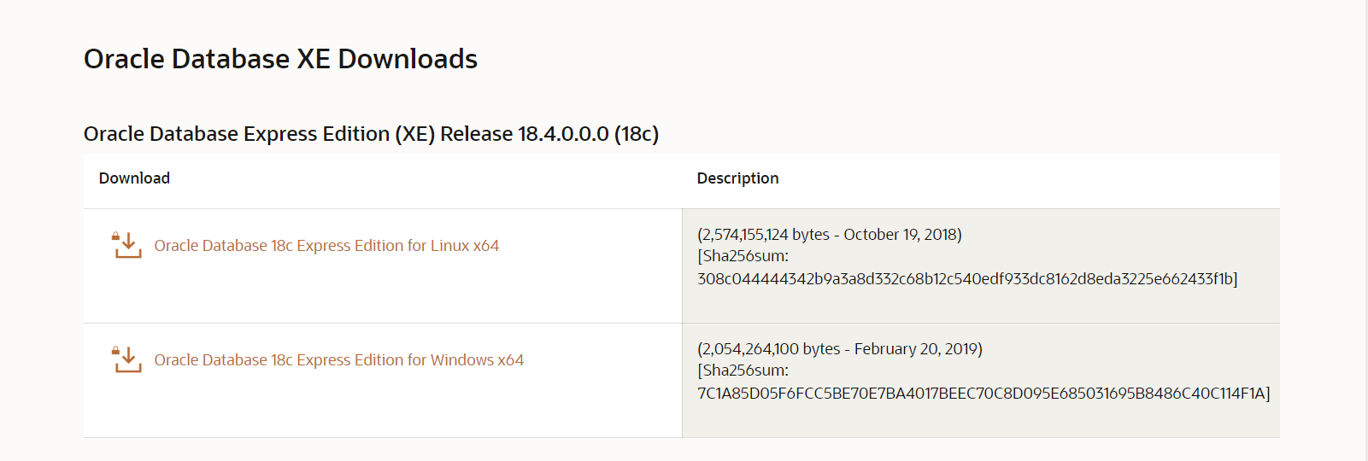
6. Accept the license agreement.

**How to install the Oracle database software**

1. Start by unzipping the Oracle database download into a folder of your choice.
2. Find setup.exe and click it.



1. The installation will begin. All steps will be covered.
2. Click next at the welcome screen. 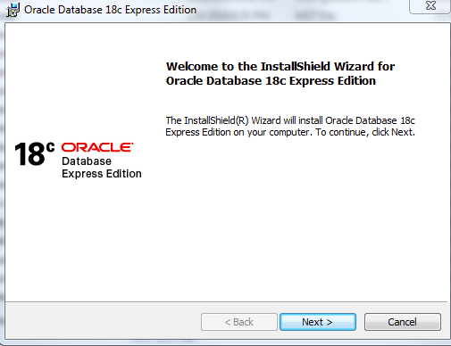
3. Select a password for the database. Then click next.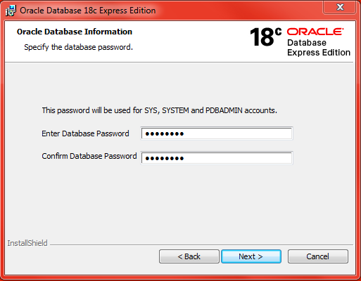
4. Read and accept the license agreement. Then click next.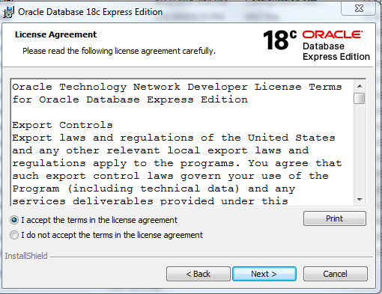
5. Select your destination folder. Click next to proceed. Then click install. 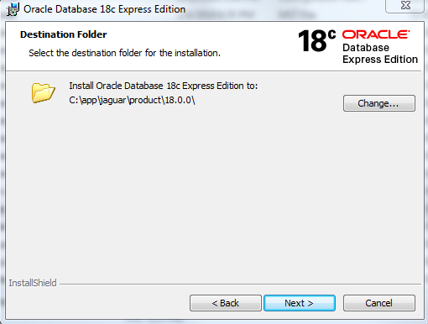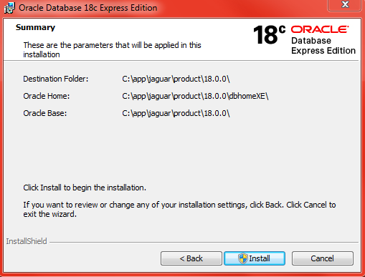
6. The installation will begin progressing. Wait patiently for it to finish. It may take several minutes.

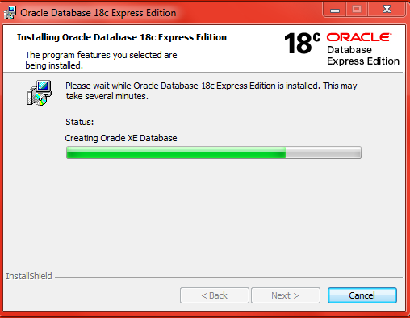

1. The installation is complete click finish to end the program.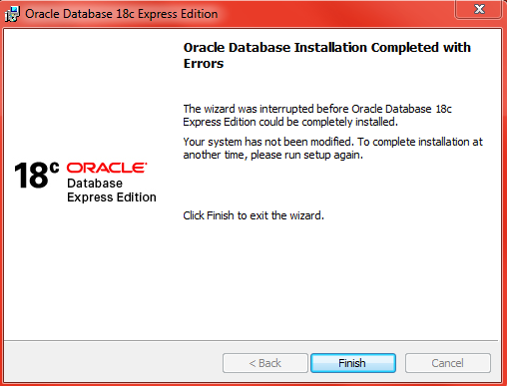

**To install SQL developer.**

1. Visit the Oracle homepage.
2. Type SQL developer download.
3. Click Oracle SQL developer downloads.
4. Find the version for your machine and click download. 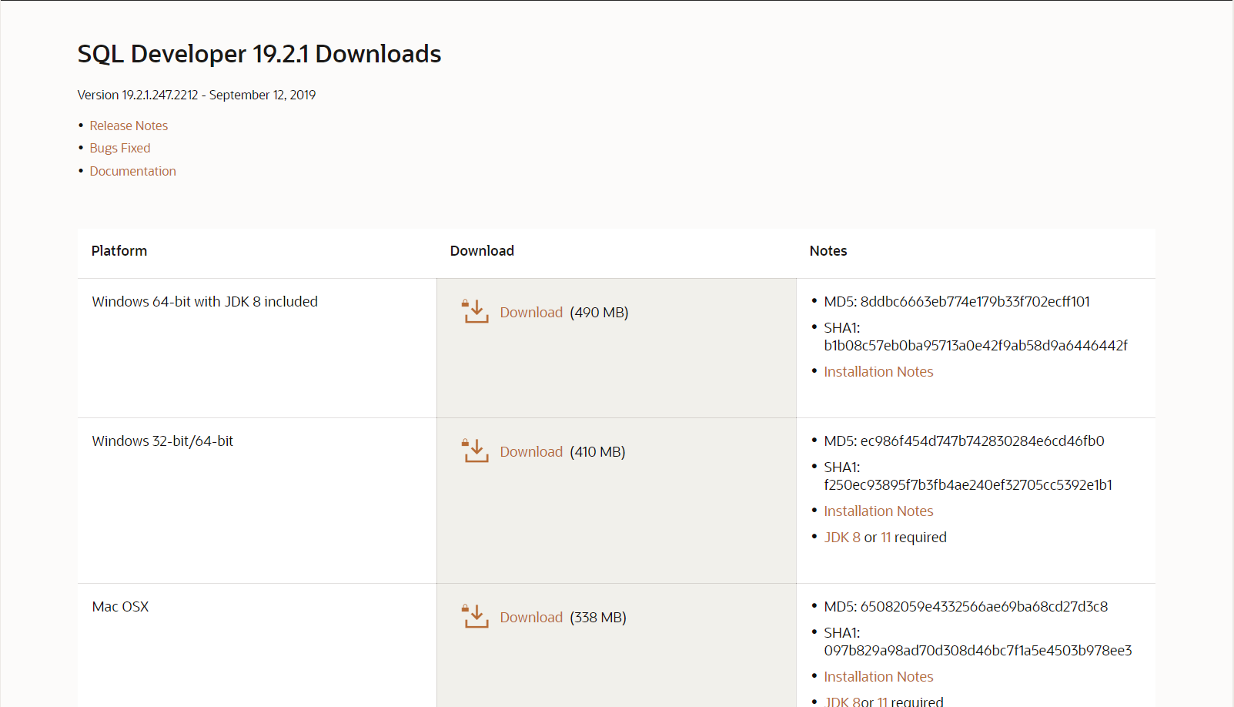
5. Accept the liscense agreement and click download.
6. Unzip the contents into a folder of your choice.
7. You may want to make a shortcut to the sqldeveloper.exe file.

**To create the database**

1. Start sqldeveloper.exe.
2. Look on the left to find the plus sign for connections. Click that plus icon. 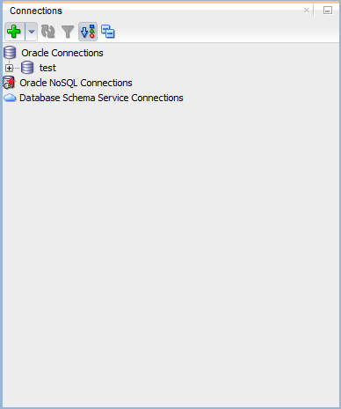
3. From here create a new connection. Create a database name, username, and password. Then click connect to connect to the database.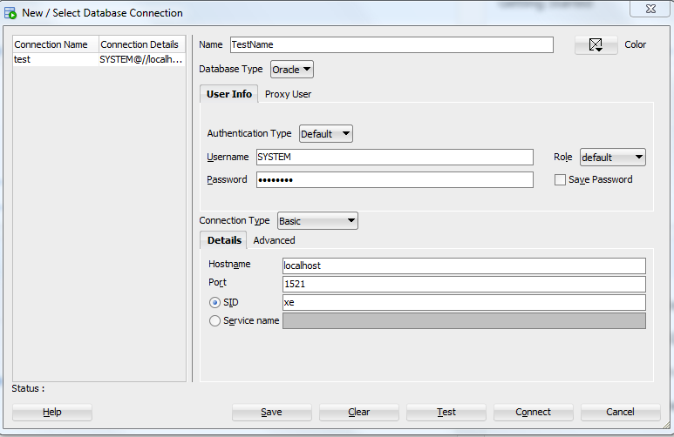
4. Next is creating the database tables and rules. Double click the database connection you have made. Go to file in the top left of sql developer. Then click open. From here navigate to where you have BudgetTracker.sql saved and click open.
5. Now locate the arrow next to worksheet. Click the run script button to the right or press F5. This will create the database tables and rules. 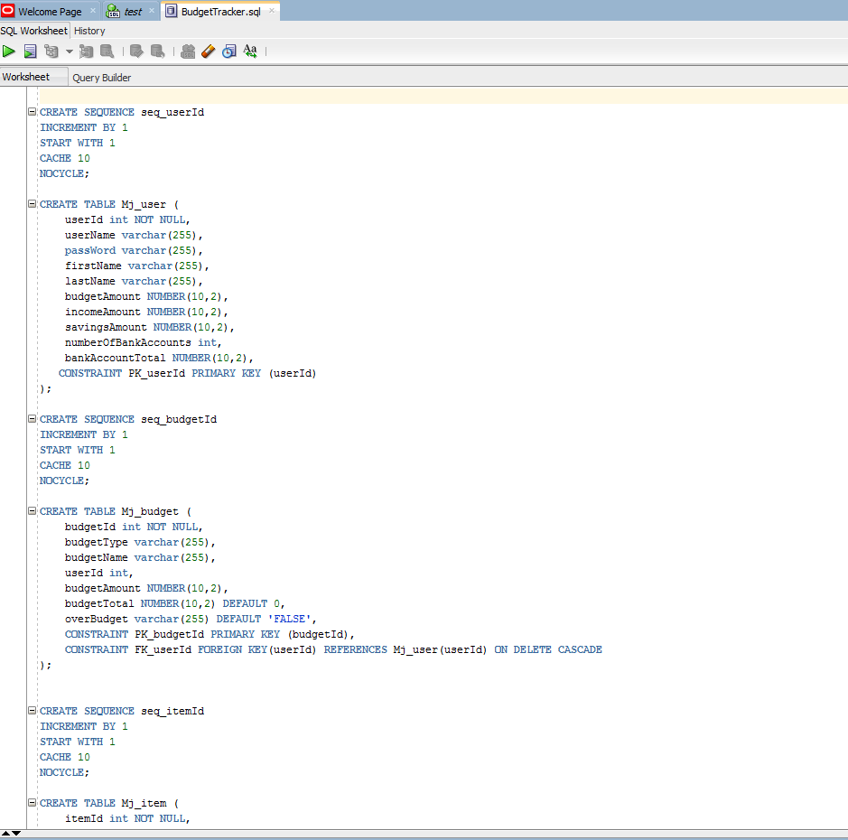
6. You can now exit sql developer.

**Installing Budget Tracker**

1. Create a folder to hold the BudgetTracker.jar file.
2. Place the BudgetTracker.jar file into the folder.
3. Double click the BudgetTracker.jar file to run the program.
4. If this doesn’t work run the run.bat file to run BudgetTracker.jar.

**Installing Increment 2**

1. Remove the old executable jar. The jar is named BudgetTracker.jar
2. Place the new executable jar named BudgetTracker.jar in its place.

**To remove the old executable**

1. Find the folder you have BudgetTracker.jar saved to.
2. Locate BudgetTracker.jar inside that folder.
3. Delete BudgetTracker.jar and only BudgetTracker.jar

**To Add new executable**

1. Find the location of the new BudgetTracker.jar file.
2. Move or copy this file to the folder where BudgetTracker.jar was stored.
3. Double click on the new BudgetTracker.jar file to run the program.
4. If that didn’t work run the run.bat file to run BudgetTracker.jar

**Installing Increment 4**

There are three steps to this increment.

1. Remove the previous executable file.
2. Add the new executable file.
3. Apply the new database additions.

**To remove the old executable file**

1. Find the folder you have BudgetTracker.jar saved to.
2. Locate BudgetTracker.jar inside that folder.
3. Delete BudgetTracker.jar and only BudgetTracker.jar

**To add the new executable file**

1. Find the location of the new BudgetTracker.jar file. It may be named BudgetTracker-2.jar
2. Rename it to BudgetTracker.jar.
3. Move or copy this file to the folder where the original BudgetTracker.jar was stored.
4. Double click on the new BudgetTracker.jar file to run the program.
5. If that didn’t work run the run.bat file to run BudgetTracker.jar. This only works if the file is named BudgetTracker.jar

**Applying the new database additions**

1. Find where you have SQL developer installed.
2. Start the SQL developer program.
3. Make sure to double click on the proper database connection. It is located in the connections tab to the left.
4. Go to file in the top left of sql developer. Then click open. From here navigate to where you have Increment_4.sql saved and click open.
5. Now locate the arrow next to worksheet. Click the run script button to the right or press F5. This will add the sequence and table to the database.

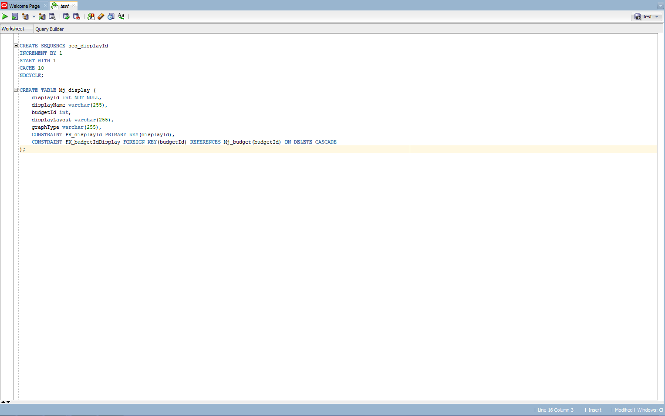

1. You can now close sql developer.

**Installing Increment 6**

There are three steps to this increment.

1. Remove the previous executable jar file.
2. Add the new executable jar file.
3. Apply the new database additions.

**To remove the old executable file**

1. Find the folder you have BudgetTracker.jar saved to.
2. Locate BudgetTracker.jar inside that folder.
3. Delete BudgetTracker.jar and only BudgetTracker.jar

**To add the new executable file**

1. Find the location of the new BudgetTracker.jar file. It may be named BudgetTracker-4.jar
2. Rename it to BudgetTracker.jar.
3. Move or copy this file to the folder where the original BudgetTracker.jar was stored.
4. Double click on the new BudgetTracker.jar file to run the program.
5. If that didn’t work run the run.bat file to run BudgetTracker.jar. This only works if the file is named BudgetTracker.jar

**Applying the new database additions**

1. Find where you have SQL developer installed.
2. Start the SQL developer program.
3. Make sure to double click on the proper database connection. It is located in the connections tab to the left.
4. Go to file in the top left of sql developer. Then click open. From here navigate to where you have Increment_6.sql saved and click open.
5. Now locate the arrow next to worksheet. Click the run script button to the right or press F5. This will add the sequence and table to the database.

